Report
Of
Python Developer Internship
Submitted
To
School of Computer Science and Engineering
IILM University, Greater Noida, U.P.
In partial fulfilment of the requirement of degree of
B.Tech CSE

By
Roll Number of Student: 2410031464
Name of Student: MD ARIF HUSSAIN
Section: 3CSE24
Batch: 2026-27

CANDIDATE'S DECLARATION
I, MD ARIF HUSSAIN, do hereby declare that the internship report titled “Python Developer Internship” has been completed by me to fulfil the requirement for the award of the degree of Bachelor of Technology in CSE. All the references have been quoted and I have not taken as such any material from any other source. I affirm to you that this report is my own and has not been submitted to any other institute for any degree/diploma requirement and further I shall be solely responsible for any kind of copyright violation in this regard.
Signature
Student Name: MD ARIF HUSSAIN
Roll No.: 2410031464

ACKNOWLEDGEMENT
I am using this opportunity to express my gratitude to everyone who supported me throughout the Internship Program. I am thankful for their aspiring guidance, invaluably constructive criticism and friendly advice during this work. I am sincerely grateful to them for sharing their truthful and illuminating views on a number of issues related to this work.
I express my gratitude to my parents for their blessings.
Signature
Student Name: MD ARIF HUSSAIN
Roll No.: 2410031464

INTERNSHIP COMPLETION CERTIFICATE
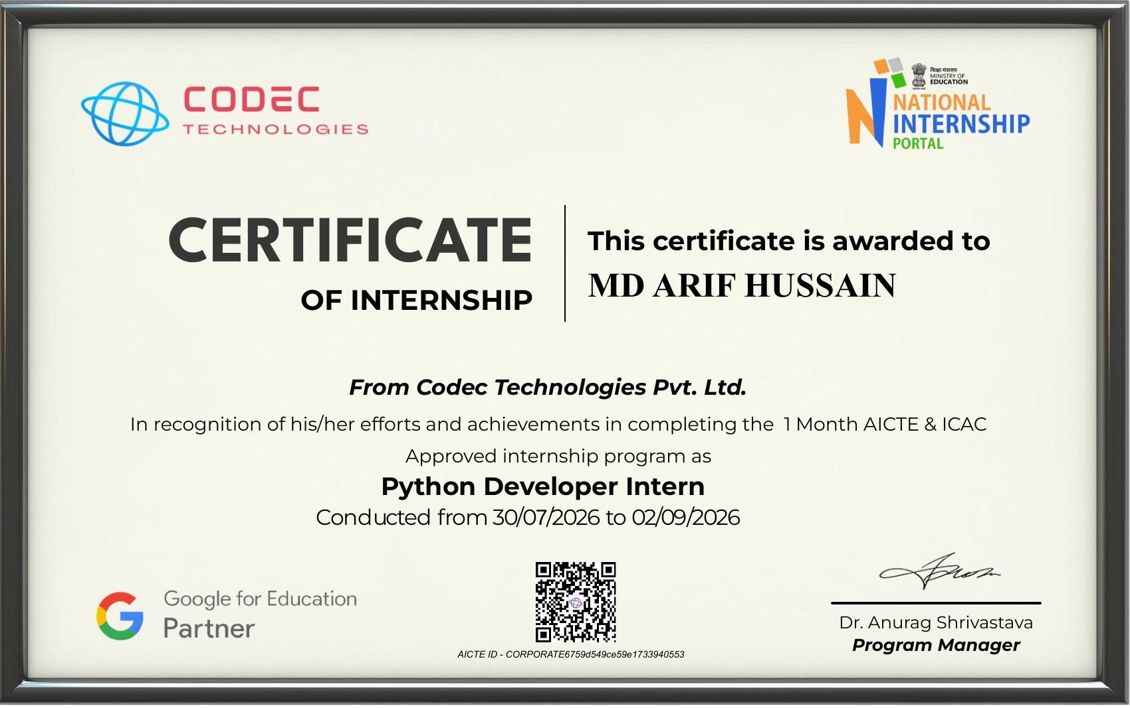

TABLE OF CONTENTS
Chapter No. | Chapter Name | Page Nos.
 | Cover Page | ----
1. | Candidate's Declaration | i
2. | Acknowledgement | ii
3. | Internship Completion Certificate | iii
4. | Project Description | 1
 | 4.1 Introduction | 1
 | 4.2 Organization Profile | 1
 | 4.3 Problem Statement | 1
 | 4.4 Project Objectives | 1
 | 4.5 Scope of the Project | 2
 | 4.6 Technologies and Tools Used | 2
 | 4.7 System Architecture | 2
 | 4.8 Methodology | 3
 | 4.9 Expected Outcomes | 3
 | 4.10 Certificates of Completion and Communication Proof | 3
5. | Bibliography/References | 4

4. PROJECT DESCRIPTION
4.1 Introduction
This report presents a summary of the internship undertaken as a Python Developer Intern with Codec Technologies Pvt. Ltd., carried out under the AICTE & ICAC approved internship program facilitated through the National Internship Portal. The internship, conducted from 30 July 2026 to 02 September 2026, provided practical, industry-oriented exposure to the Python programming language and its application in real-world software development. The objective of this report is to document the learning outcomes, technical work, and overall experience gained during the course of the internship, in partial fulfilment of the requirement for the degree of Bachelor of Technology in Computer Science and Engineering at IILM University, Greater Noida.
4.2 Organization Profile
Codec Technologies Pvt. Ltd. is a technology and skill-development organization that conducts structured, mentor-led internship and training programs for engineering and computer science students. In collaboration with the National Internship Portal and in line with AICTE and ICAC guidelines, the organization designs its programs to bridge the gap between academic learning and industry-relevant technical skills, covering domains such as Python programming, data science, web development, and software engineering. The internship program is delivered with the support of recognized education partners and follows a curriculum that combines guided learning modules with hands-on project work, culminating in an assessment and a certificate of completion.
4.3 Problem Statement
Engineering students, while trained in the theoretical foundations of computer science, often lack sufficient hands-on exposure to industry-standard programming practices, tools, and workflows before entering the job market. There is a need for a structured, practice-oriented program that allows students to apply core Python programming concepts to real, project-based problems, thereby developing the practical competence expected of an entry-level Python developer.
4.4 Project Objectives
- To strengthen core Python programming concepts, including data types, control structures, functions, and object-oriented programming.
- To gain practical experience in using Python for problem-solving, automation, and application development.
- To learn the use of industry-standard tools, libraries, and version control systems used in professional software development.
- To develop the ability to design, implement, test, and document a small-scale Python-based project.
- To understand professional workflows, including requirement analysis, coding standards, and collaborative development practices.
4.5 Scope of the Project
The scope of the internship was limited to building a foundational and practical understanding of Python development within the duration of the program. It covered core language fundamentals, working with standard and third-party libraries, basic application/script development, and an introduction to collaborative development practices using version control. The work carried out during the internship serves as a foundation for further, more advanced application development and is not intended to represent a full-scale, production-ready software system.
4.6 Technologies and Tools Used
- Programming Language: Python 3
- IDE / Editor: Visual Studio Code / PyCharm
- Libraries: NumPy, Pandas, Matplotlib (as applicable to the assigned tasks)
- Version Control: Git and GitHub
- Documentation Tools: Jupyter Notebook, MS Word
- Operating System: Windows
4.7 System Architecture
The work carried out during the internship followed a simple, modular structure typical of small-scale Python applications, consisting of three broad layers: (i) an Input/Interface layer responsible for accepting user input or source data, (ii) a Processing/Logic layer containing the core Python functions and modules that implement the required logic, and (iii) an Output/Storage layer responsible for displaying results or storing processed data. This layered approach was followed to keep the code modular, readable, and easy to test and maintain.
4.8 Methodology
- Requirement Understanding: Reviewing the tasks and learning modules assigned as part of the internship curriculum.
- Learning Phase: Studying core Python concepts and relevant libraries through guided sessions and self-study.
- Implementation: Writing, testing, and debugging Python code for the assigned tasks/mini-projects.
- Testing: Verifying the correctness of the code using sample inputs and edge cases.
- Documentation: Preparing notes and this report to record the work carried out and the outcomes achieved.
4.9 Expected Outcomes
- A strengthened, practical understanding of Python programming fundamentals and best practices.
- Hands-on experience in developing, testing, and documenting small Python-based tasks/projects.
- Familiarity with industry-standard tools such as Git/GitHub for version control.
- Improved problem-solving and independent-learning ability in a professional environment.
- Successful completion of the AICTE & ICAC approved internship program with a certificate of completion.
4.10 Certificates of Completion and Communication Proof
The Internship Completion Certificate issued by Codec Technologies Pvt. Ltd., certifying the successful completion of the “Python Developer Intern” program conducted from 30/07/2026 to 02/09/2026, has been attached in Chapter 3 of this report.

5. BIBLIOGRAPHY / REFERENCES
1. Python Software Foundation. Python 3 Documentation. Available at: https://docs.python.org/3/
2. GeeksforGeeks. Python Programming Language Tutorials. Available at: https://www.geeksforgeeks.org/python-programming-language/
3. W3Schools. Python Tutorial. Available at: https://www.w3schools.com/python/
4. NumPy Developers. NumPy Documentation. Available at: https://numpy.org/doc/
5. Pandas Development Team. Pandas Documentation. Available at: https://pandas.pydata.org/docs/
6. Codec Technologies Pvt. Ltd. Internship Program Learning Modules and Session Material, 2026.

